**How to append the content to a file using tee command.**

The tee command in Unix-like operating systems is typically used to read from standard input and write to both standard output and one or more files simultaneously. To append content to a file using the tee command, you can specify the -a option to indicate that you want to append to the file instead of overwriting it.

Syntax: command | tee -a filename

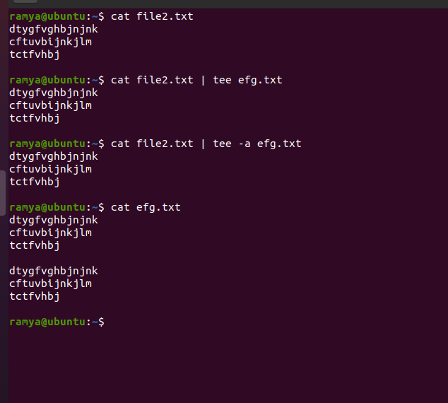

**how to search multiple patterns using grep command.**

*You can search for multiple patterns using the grep command by specifying those patterns as arguments or by using regular expressions. Here are a few ways to search for multiple patterns*:

**Specifying multiple patterns as arguments:**

You can provide multiple patterns as arguments to the grep command. grep will then search for lines that match any of the specified patterns.

**grep "pattern1" "pattern2" "pattern3" file.txt**

In this example, grep will search for lines in file.txt that contain "pattern1," "pattern2," or "pattern3."

**Using regular expressions:**

You can use regular expressions to search for multiple patterns using the grep command. Use the -E (or --extended-regexp) option to enable extended regular expressions, and then use the | (pipe) character to specify multiple patterns.

**grep -E "pattern1|pattern2|pattern3" file.txt**

In this example, grep will search for lines in file.txt that match any of the patterns "pattern1," "pattern2," or "pattern3."

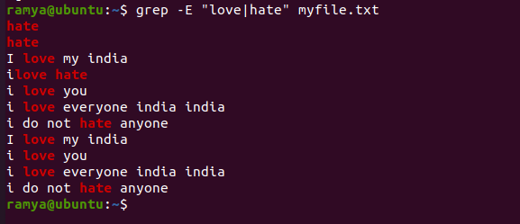

**Using a file with patterns:**

If you have a file containing a list of patterns, you can use the -f option to tell grep to read patterns from that file. Each pattern should be on a separate line in the file.

**Create a file (e.g., patterns.txt) with the patterns:**

*pattern1*

*pattern2*

*pattern3*

Then use grep with the -f option:

**grep -f patterns.txt file.txt**

This command will search for lines in file.txt that match any of the patterns listed in the patterns.txt file.

Using these methods, you can search for multiple patterns in a file or even in the output of other commands. Just replace "pattern1," "pattern2," and "pattern3" with the specific patterns you want to search for.